|  |
| --- |
| Combining Eco-Driving and eco-feedback technologies in Organizations: *Introducing a concept targeted at improving the fuel efficiency of corporate car drivers*  Johannes Tulusan1, Hannah Steggers2, Thorsten Staake3, Elgar Fleisch1,3  1 Institute of Technology Management, St. Gallen University – Switzerland  johannes.tulusan@unisg.ch  2 SAP Research, SAP (Schweiz) AG – Switzerland  hannah.steggers@sap.com  3 Bits to Energy Lab, ETH Zurich University – Switzerland  {tstaake, efleisch}@ethz.ch  **Abstract.** The escalating rate of energy consumption underpins the need to set goals that promote a reduction in CO2 emissions. In 2011 the transport sector contributed 23% to the total EU CO2 emissions; road transport alone was responsible for 71% of this 23% compared to 12% from aviation transport. Corporate car drivers drive, on average, three times more than private car users in Europe (21,500 miles). An improvement in their fuel efficiency, by encouraging sustainable driving using eco-feedback technologies, has the potential to reduce CO2 emissions and promote fuel cost savings of 1% to 8%. This paper evaluates these findings further by drawing on organizational and conceptual elements that provide a foundation through which a fuel improvement concept can be applied within an organization using eco-feedback technologies. The theoretical analysis of these findings, with reference to the Feedback Intervention Theory and appraisal of corporate car drivers’ extrinsic and intrinsic motivation, revealed that it is imperative to raise driver’s awareness of their fuel consumption. Drivers’ concerns regarding management monitoring leading to control and punishment (if their fuel efficiency has not improved) must be addressed. It is essential that an organizational roll-out is not associated with punishments, but focused on motivating employees by providing extrinsic motivation through realistic goal setting and constructive feedback.  Keywords: Eco-feedback technologies, smartphones, ecological driving, fuel efficiency concept, corporate car drivers, organizations |

1. **Introduction**

The increasing demand for energy appeals for goals to be set targeting a reduction in CO2 emissions. Of the 23% that the transport sector contributed to the EU CO2 emissions in 2011, road transport was responsible for 71% (European Commission, 2011). In Germany one quarter of the three million newly registered cars are predicted to be corporate cars (Kraftfahrt-Bundesamt, 2012). Corporate companies are interested in reducing their carbon footprint for both financial and environmental reasons. For instance, in our case study, a global software company’s corporate cars are responsible for 23% of the company’s total CO2 emissions, and with petrol costs of 42.5 million Euros in 2011 (Sustainability Manager Software Company, 2012), an improvement in fuel efficiency is attractive.

Potential solutions like purchasing new vehicles with the latest on-board eco-technologies require substantial one-time investments. A more costs attractive alternative is to provide employees with an eco-driving training which educates them about eco-friendly driving techniques. This option has been explored by research that focused on offering such trainings to private car users; improvements in fuel efficiency of 5-15% were achieved (Onoda, 2009), but motives to embrace eco-friendly driving recommendations were rooted in the participants’ desire to profit from the financial rewards (Van der Voort et al., 2001).

Corporate car drivers cannot be enthused by financial rewards as their fuel costs are reimbursed by their company. Eco-driving training does present the potential to stimulate motivation for participants’ to reduce their fuel consumption by promoting a more sustainable driving style, but this can be costly both financially and with regards to time when considering a larger corporate fleet. For this reason, mobile technologies provided an opportunity to address fuel efficiency. The use of mobile technologies to promote eco-driving concepts amongst corporate car drivers indicated an improvement in fuel efficiency of between 3-8% (Siero et al., 1989; Tulusan et al., 2012). This approach requires a smaller financial investment and less time to implement due to the comparably low cost for the smartphone application and the high penetration rate of smartphones.

This paper builds on existing findings in the literature, which claim that eco-feedback technologies can enable corporate car drivers to improve their fuel efficiency. The focus lies within the conceptual aspects, how should an eco-driving concept supported by eco-feedback technologies be rolled-out in an organization? In order to answer this research question, a qualitative research approach was chosen. A post survey with 24 out of 25 corporate car drivers and semi-structured interviews with 15 of the participants were conducted to unveil their experiences, opinions, and concerns.

Findings were analyzed applying the Feedback Intervention Theory (FIT) by Kluger & DeNisi (1996) which evaluates changes in behavior as a consequence of feedback interventions. In relation to the information communication technologies (ICT) research domain, the FIT highlighted “that computer-mediated feedback will lead to a focus on the task” (Stoney Alder, 2007, p.163). This in turn can lead to an improvement in performance, i.e. an improvement in corporate drivers’ fuel efficiency. The theoretical contribution lies in the computer-mediated feedback addressing energy reduction; this was not explored by Kluger & DeNisi (1996). The concept of extrinsic and intrinsic motivation was also applied to the findings to attain a greater understanding of how a change in driving behavior may be triggered.

Findings highlight the importance of raising corporate car drivers’ awareness of their fuel consumption. Also, punishment must be eliminated from the process and extrinsic motivation offered by setting realistic fuel-saving goals, and exposing fuel consumption/ costs and provide personalized feedback. These measures afford drivers a feeling of autonomy and competence, which enhances their intrinsic motivation to commit to long-term improvements.

1. **Related Work**
   1. **The Eco-Driving Concept**

Eco-driving is a way to reduce fuel consumption in the road transport sector. The essence of the eco-driving concept is enabling drivers to change their driving style to a more fuel efficient approach by providing advice and feedback (Boriboonsomsin et al., 2010). Advancements in engine technologies and vehicle performance have a significant influence on the vehicles’ fuel efficiency and CO2 emissions without drivers needing to adjust their driving behavior (Austrian Energy Agency, 2012). However, drivers themselves, either positively or negatively, have a strong influence on the fuel consumption of up to 30% (Romm and Frank, 2006). Eco-driving aims to tackle this gap by adapting drivers’ driving style to become more eco-efficient (SenterNovem, 2006). The eco-driving concept is based on following basic rules: a) anticipate traffic flow, b) maintain a steady speed at low revolutions per minute (RPM), c) shift up early, and d) check tyre pressures frequently. These rules illustrate that “eco-driving means smart, smooth and safe driving at lower engine speeds (1,200 – 2,500 revolutions per minute), which saves 5 - 10% fuel on average.” (SenterNovem, 2006, p.6). Further studies in Europe have proven that applying the eco-driving concept can save up to 15% of fuel consumption (Onoda, 2009). The benefits are evident in the following categories: saving costs, reducing fuel consumption and CO2 emissions, a more comfortable driving style, and improved road safety (SenterNovem, 2006). These benefits can only be realized when providing advice and guidance to drivers through various methods. Due to the energy reduction debate, the popularity of eco-driving has increased in the last few years; consequently, different training possibilities, information material (brochures or online) and driving simulators are available for educating, informing, and advising drivers (Onoda, 2009). Recently, eco-driving practices have been tested with the support of eco-feedback technologies revealing an improvement in corporate car drivers’ fuel efficiency of up to 7.3% (Boriboonsomsin et al., 2010; Siero et al., 1989).

* 1. **Mobile Eco-Feedback Technologies**

As previously stated, the eco-driving concept involves enabling drivers to change their driving style to a more fuel efficient one by providing advice and feedback. Advice is mostly given through various eco-driving training approaches. Offering drivers feedback about their driving habits by applying information communication technologies is limited. (GreenRoad 2008, p.12) suggested “a device is required that gives the driver immediate and accurate fuel consumption information, yet is not a distraction from safe driving”. A highly effective way to give feedback is using eco-feedback technologies (Froehlich et al., 2009). According to Froehlich et al. (2009), eco-feedback technologies increase the awareness of someone’s knowledge about sustainability and it’s own behavior; this is defined as ‘environmental literacy gap’. The goal is to modify behavior, thereby reducing the impact of human behavior on the environment. These technologies potentially raise environmental awareness by exposing the individual’s impact on the environment as a consequence of their various driving habits. Within the minority of studies that reviewed on-board systems, a 6% improvement in the subject’s fuel efficiency after partaking in an eco-driving training program and having access to a vehicle with an on-board feedback device which provided them with instantaneous fuel consumption information was highlighted (Boriboonsomsin et al., 2010). Nevertheless, eco-driving advisor in-vehicle technologies are still expensive and drivers may not be willing to pay approximate cost of 1,100 Euros (costs of Ecodrive III system) for an on-board device to simply improve sustainable driving (Autoflotte, 2008). Cheaper alternatives are attractive and with the advancements in the global positioning system (GPS) and acceleration technologies for smartphones, eco-efficient mobile feedback technologies that provide constant driver-oriented feedback have the potential to assist users to reduce their fuel consumption. A significant advantage of such smartphone applications lies in its value for money (i.e. costs between 0 to 10 Euros), as one does not have to purchase a new vehicle with the latest on-board technologies or a high-cost device.

For the purpose of this research an eco-driving smartphone application developed by DriveGain Ltd. was chosen as it incorporates all basic eco-driving rules, has an extensive car model database and offers different types of feedback. Figure 1 shows the interface of the application. It provides various feedback meters, direct or indirect, about ecological driving aspects.

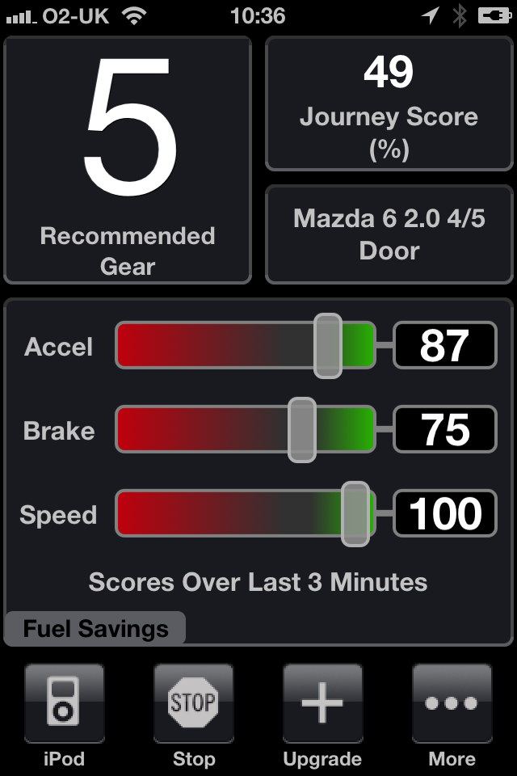

Figure 1: DriveGain Application Interface (Drive Gain Ltd, 2011)

The illustration shows that the application provides feedback on acceleration, braking and speed, measured by the GPS sensor. In addition, it has a recommended gear feature which prompts the driver when to shift gears up or down. For cars with automatic gearboxes only two gears, P for parking and N for driving, are shown. The journey score, 0 (least) and 100 (most ecological), combines the data from: acceleration, braking and speed, and is calculated with respective to the car model chosen. The journey score, together with values reflecting vehicle speed, acceleration and braking are all saved by the application. Detailed data regarding the usage of the application is also collected by the application. The saved data per trip are: a) distance (in meters), b) duration (in minutes), c) start / end location, d) overall time e) acceleration / braking / average speed figures.

* 1. **Overview of case study**

The global software company focuses on five key areas to reduce their environmental impact in 2012: Business flights, employee commuting habits, renewable energy, data center projects, and mobility solutions. The focus area of mobility solutions is related to finding alternatives to driving approaches (e.g. car sharing), and to reduce vehicle emissions (e.g. electric cars in fleet, improve fuel efficiency of existing fleet, reduction of CO2 allowance for a new car). The reduction of the corporate cars CO2 emissions could significantly contribute to the overall reduction in the company’s greenhouse gas footprint. The company has 19,100 fleet cars worldwide. The number increased by 10% in 2011 and is predicted to rise once again in 2012 (Sustainability Manager Software Company, 2012). These 19,100 corporate cars were responsible for 23% (111 kTons) of the company’s total global CO2 emissions in 2011[1] (Software Company, 2012). The contribution can be seen in Figure 2.

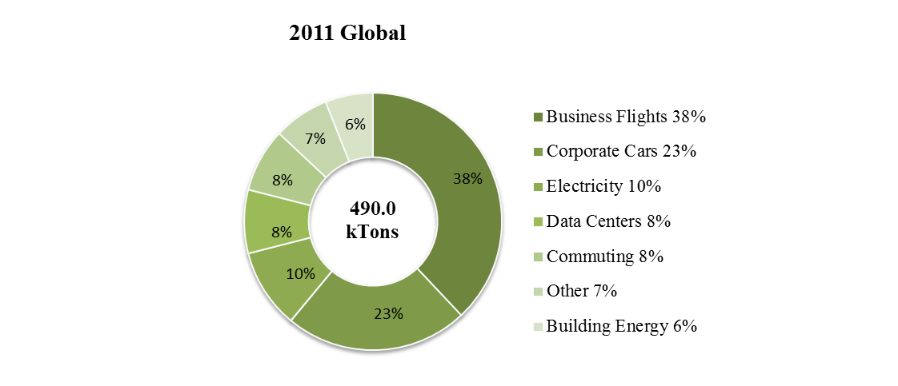

Figure 2: 2011 Company’s Global CO2 Emissions

The high volume of CO2 emissions expelled by the 19,100 corporate cars indicates an urgent need to address effective sustainable mobility solutions. The first approach was to reduce the CO2 emission cap guidelines for new corporate cars. However, this guideline is applicable to newly purchased cars, and as corporate cars are driven for up to five years or 150.000 km, implementation is gradual over time. It is realized that a more immediate approach is required to modify driving behaviors. Current initiatives focus on classroom training strategies, such as eco-driving, which requires drivers to invest time and money. An alternative cost-efficient approach would be eco-feedback technologies that inform drivers about their fuel consumption and eco-driving techniques.

It is important to understand the special criteria corporate car drivers represent. Corporate car drivers are defined as drivers who drive a corporate car largely for work-related travel as well as private transportation. In Europe, they drive on average more than 34,000 km/year. In comparison, private car drivers drive on average less than half this distance, 13,500 km/year (DTLR, 2012). Corporate car drivers pay a monthly leasing fee for their car of between 200- 600 Euros. This fee covers petrol costs related to business mileage, maintenance and service costs, depending on the car-type and country. The CO2 emissions of the car have an impact on the value of the leasing fee; the higher the emissions, the higher the fee. With this in mind, it is evident that corporate car drivers have limited incentives to modify their driving habits in order to be more eco-friendly. Hence, alternative approaches to promote fuel efficiency are required for this subject group.

1. **Research Questions / Objectives**

As already indicated, the software company is committed to further reduce its environmental impact, especially its CO2 footprint. Apart from ecological advantages are also economic benefits connected with the reduction of the drivers’ fuel efficiency. The company could save 16,712.5 tons of CO2 emissions and 1.67 million Euros, when improving the drivers’ fuel efficiency by 0.25 liter per 100 km. One reduction possibility is enabling the corporate car drivers to drive more sustainable in order to reduce CO2 emissions, fuel consumption and petrol expenditures. The problem is how to influence corporate car drivers to actually change their driving habits into a more sustainable driving style. The strategy chosen is to influence the drivers by using an eco-feedback technology, namely an eco-driving smartphone application. An improvement of 3.23% was achieved (Tulusan et al., 2012). The eco-driving smartphone application provided direct and indirect feedback to the driver during driving. Apart from analyzing whether the smartphone application has a positive impact on corporate car drivers’ fuel efficiency the problem of how to implement such a fuel savings concept within the organization has to be addressed. The results are important for the software company, as the company currently has 19,100 corporate cars globally and is interested in the conceptual aspect of how to implement an eco-driving project supported with new technologies in the long-term.

The main goal of this paper is therefore deriving recommendations how to roll out a fuel savings concept within the organization. For this purpose following research question have to be answered:

*RQ: How should an eco-driving concept supported by eco-feedback technologies be rolled-out in an organization?*

1. **Conceptual Framework**
   1. **Feedback Intervention Theory**

Van Velsor et al. (1997, p.36) define feedback as “information about a person’s performance or behavior, or the impact of performance or behavior, that is intentionally delivered to that person in order to facilitate change or improvement”. Kluger and DeNisi (1996) applied the Feedback Intervention Theory (FIT) to appraise how feedback interventions provoked driving motivation and behavior, determined by comparing feedback to goals, standards or norms. They defined feedback interventions (FIs) as “actions taken by (an) external agent(s) to provide information regarding some aspect(s) of one’s task performance” (Kluger & DeNisi, 1996, p.255). Henceforth, FIs are applied to influence individual’s task performance and motivate them to change their actual behavior; this is referred to as ‘knowledge of results' (KR). Interventions may encompass a broad spectrum of tasks that are elicited by intent from an external agent. Kluger & DeNisi (1996) proclaimed five basic arguments for the FIT (Shute, 2007, p.21):

* + “Behavior is regulated by comparisons of feedback to goals or standards.
  + Goals or standards are organized hierarchically.
  + Attention is limited and therefore only feedback-standard gaps that receive attention actively participate in behavior regulation.
  + Attention is normally directed to a moderate level of the hierarchy.
  + FIs change the locus of attention and therefore affect behavior.”

The theory claims that actions are goal directed and that behavior, therefore performance, is regulated by the individuals’ comparisons between their own standards and the feedback they receive, in which feedback can symbolize external goals set (Kluger & DeNisi, 1996). A theoretical assumption made in the research is that “FIT predicts that computer-mediated feedback will lead to a focus on the task” (Stoney Alder, 2007, p.163), and this in turn could lead to an improvement in task performance, i.e. driving behavior. This research builds on the literature by evaluating the feedback provided by eco-feedback technologies. Feedback through information communication technologies is recognized as part of the concept of computer performance monitoring (CPM) evaluated by Nussbaum and duRivage (1986) and Stoney Alder (2007). CPM enables organizations to provide their employees with information about their personal performance by collecting relevant data when working. This improves their awareness of areas for development and enables them to modify their behavior when necessary (Grant & Higgins, 1989). The FIT can be used to evaluate changes in task performances (i.e. change of driving behavior) with respect to eco-feedback technologies.

* 1. **Management Level vs. Personal Motivation**

Understanding what motivates an individual is a complex task. Management must understand which factors, intrinsic or extrinsic, motivate their employees (Beswick, 2007). Extrinsic motivation involves motivating employees using external rewards (i.e. financial incentives or extra days off) and/ or recognition (i.e. participating in important meetings) (Zahorsky, 2010). The disadvantage of this form of motivation is that the employees focus on the reward and not on the action itself (Beswick, 2007). Intrinsic motivation stems from within the person and therefore satisfaction derives from completing the task itself (Zahorsky, 2010), i.e. contributing to the driver’s self-esteem. Extrinsic motivation can enhance intrinsic motivation when applied correctly.

De Young (1986) suggested that intrinsic motivation encourages environmentally responsible behavior; individuals do not wait for rewards to act environmentally responsible, but “seem to derive personal satisfaction from the very activities that others so often try to externally reinforce” (De Young, 1986, p.289). Studies in home energy savings discovered that people were increasingly motivated to save energy and be environmental friendly when they receive personalized information about their energy consumption (Shipworth, 2002). Users need to understand the information (Shipworth, 2002) and feel they have freedom of choice and control (Rotter, 1966).

The chosen sample for this research raises questions about how to motivate corporate car drivers to drive sustainably given that there are no obvious extrinsic motivational factors (i.e. monetary rewards). It is necessary to support these individuals in developing their own intrinsic motivation to drive sustainably, as recommended by De Young (1986). Siero et al. (1989) concluded, although it is important for management to provide task assignments by setting feasible goals and information, they must capture employees’ intention by reinforcing that their energy-saving driving behavior is an integral part of their job. Caution must be exercised to avoid external control (Amabile, 1993); the driver must feel a sense of autonomy, and information must clear for them to understand and utilize constructively. The implementation of an eco-driving concept within an organization requires management to understand what motivates their employees and meets their needs.

1. **Data Collection Method and Data Analysis**

The chosen form of semi-structured interviews was highly important in order to give the interviewee certain guidance, but also be able to react with different questions on their answers (Keller & Conradin, 2010). The questions for the interviews regarding the eco-driving smartphone application were based on the interviewees’ answers in the survey conducted beforehand. Apart from receiving feedback to the DriveGain application, the interviews purpose was to reveal conceptual concerns that have to be considered when implementing a fuel improvement/ CO2 reduction initiative within an organization. The questions were e.g. asking if any other guidelines would be relevant for an organizational roll out of a fuel savings concept or the interviewees’ attitude towards management interventions.

A grounded theory analysis was used to appraise the data collected in the follow-up interviews (Babchuk, 1997). The process of open and axial coding is defined as “microanalysis which consists of analyzing data word-by word” and is “the meaning found in words or groups of words” (Strauss & Corbin, 1998, pp.65-68). The interview data was classified into topics and reviewed to unveil emerging codes; this is defined as the coding process. The axial coding process followed. This enabled a systematic analysis and constant comparison of coded segments to be made. The result was a reduction in the coded segments and the identification of relationships/ abstract concepts among them (Moghaddam, 2006). Finally, interpretation of the remaining categories was possible and the core categories were defined.

1. **Findings & Analysis**
   1. **Opinions and Concerns regarding Eco-Driving Concept**

The coding process revealed that the core categories drivers are concerned with can be divided into Driver and Management Levels. The categories with the assigned codes are shown in Table 1.



Table 1: Coding Outcome with Core Categories

Participants felt the biggest benefit of the eco-driving smartphone application was its ability to raise awareness (stated 13 out of 15 (highest) times) and sensitize (stated 11 times). The interviews revealed that the participants’ had a positive attitude towards implementing this eco-driving concept. However, they had concerns about management interactions, guidelines defining the target reduction in CO2 emissions resulting in punishments if unmet (stated 14 times), or the greater focus being on cost savings rather than the environmental benefits.

The software company relies on their employees to visit several customers daily to generate leads or offer consulting services. For this reason, the drivers are unable to completely take control over their fuel efficiency, as this is partly dependent on where their customers are located. Depending on the destination the routes differ, traffic congestion varies impacting on the drivers’ driving behavior. Participants stated that this is the main reason why they feel management should not punish drivers for not reaching fuel efficiency improvement goals set.

It is necessary to take into account that a principle factor in corporate car drivers’ daily routine and role is time. 15 statements were made indicating that when they have driven an immense number of kilometers every day, it is more important for them to reach home earlier than improving their fuel efficiency. Overall, participants had a positive attitude towards management interventions in the form of goal-setting. They stated that setting realistic goals was necessary to enhance their focus and motivation to drive more sustainable (in total stated 12 times). By comparison only 3 drivers felt that it was not favorable for management to intervene and set goals.

Feedback is beneficial when it is constructive, as it recognizes drivers’ progress and provides advice about how they can continue to improve. Feedback may be given in the form of comparison; participants specified that the comparison has to be valid, vivid and especially transparent (stated 10 times). The most suitable comparison was felt to be between drivers who drove the same vehicle type and model (stated 15 times), and approximately the same total number of km (stated 14 times). Most drivers specified that information provision coupled with rewards would be additionally motivational.

* 1. **Analysis of the Findings**

The FIT by Kluger & DeNisi (1996) represents five basic arguments which can be applied to explain behavioral modification by using computer-mediated feedback intervention, i.e. through an eco-driving smartphone application. It is essential to evaluate what needs to be considered when implementing an eco-driving concept within the software company. The results of this research will be discussed in relation to the five basic arguments.

*Argument 1:* *Behavior is regulated by comparisons of feedback to goals or standards.*

The first argument states that individuals have their own standards, but without appraising these against goals set and receiving any feedback on their performance, drivers’ might be reluctant to change their behavior. This underpins the essence of needing to influence corporate car drivers driving behavior through feedback interventions using an eco-driving smartphone application. The participants’ extensive driving experience has caused them to develop driving habits, which formulate their standards. The feedback participants receive is generated through the smartphone application, which compares their driving behavior with relevant eco-driving practices. This helps raise their awareness by compelling them to consider accepting the feedback given, or not, and enables them to choose to adapt their driving behavior. Improved driver awareness was attained amongst the corporate car drivers. Together with improving their fuel efficiency 80% discussed their driving behavior with friends and/ or colleagues during the treatment phase.

The perspective that behavior is regulated by comparisons between feedback and goals or standards is highly important in reverence to an organizational roll-out of an eco-driving concept. The semi-structured interviews conducted with the participants revealed that they are comfortable with management interventions in the form of goal setting as long as there were no associated punishments. These findings correspond with the FIT, which implies that employees can only be intrinsically motivated if they feel a degree of autonomy and competence in their task (Deci & Ryan, 1985a). With respect to implementation of this concept, employees should not feel controlled by external motivators (Amabile, 1993), and management must set realistic fuel efficiency improvement goals and provide constructive feedback. Siero et al. (1989) supports these findings as they concluded that it is important for management to provide task assignments and sufficient control, i.e. to set feasible goals in order to successfully implement an eco-driving program.

*Argument 2: Goals or standards are organized hierarchically.*

Individuals set their own goals and standards according to their intrinsic motivation in coherence with extrinsic goals or standards. In addition to setting these goals or standards, individuals order them hierarchically. Preferences of corporate car drivers’ personal goals or standards related to driving vary; examples are: to save as much time as possible while driving, to drive safe or to drive more efficiently (see Table 1). The field test goal was to drive more sustainably, however, when considering participants’ personal hierarchy of goals it was apparent that time took precedence for these drivers, as one interviewee highlighted: “If you are on the road a lot, the limit is reached very fast and time becomes the most important factor” (Corporate car driver 3, 2012).

*Argument 3: Attention is limited and therefore only feedback-standard gaps that receive attention actively participate in behavior regulation.*

The feedback-standard gap in this research is the disparity between eco-driving habits and corporate car drivers’ driving behavior. The eco-driving smartphone application offered eco-driving feedback during driving. This intervention was an important factor in acquiring an improvement in fuel efficiency, indicating the need to actively direct drivers’ attention to the difference between their driving habits and the goal of adapting eco-driving driving practices. As emphasized by De Young (1986), raising awareness of residents in households by providing energy consumption details can stimulate their intrinsic motivation.

Drivers also expressed that the eco-driving smartphone application raised their awareness for their own driving behavior, and concluded when considering future roll-out programs it is important to increase the awareness of which practices support eco-friendly driving. The following preferences were also expressed: receive feedback via visualization only (6 out of 7), from a weekly email (4.875 out of 7), and not necessarily auditory feedback (3.33 out of 7). Providing feedback via e-mail may be a promising supplement to enhance the feedback provided by a CPM.

*Argument 4: Attention is normally directed to a moderate level of the hierarchy.*

Company’s corporate car drivers spent most of their time on the road, driving hundreds of kilometers almost every day of their working week; 75% of the participants drove at least 30,000 – 35,000 km/year. They also had the added pressure of time and had to be punctual. This validates why time was the most important factor for corporate car drivers, as highlighted in the semi-structured interviews (see Table 1). Participants had a strong desire to reach customers on time, but also desired to reach home as soon as possible at the end of their workday. Understandably, saving time is allocated the top-spot on drivers’ goal hierarchy. FIT states that attention is not always actively directed to the highest goal, but at a moderate level (Kluger & DeNisi, 1996). Driving more eco-friendly was not the highest goal, but set at the moderate level of the hierarchy, thus attention could have been directed towards reaching the goal. The post-experimental survey indicated that participants had moderate environmental attitudes (average = 5.01 out of 7), supporting the analysis that driving more eco-friendly was at a moderate level of the hierarchy.

With respect to management interventions argument 4 provides the protocol to set goals that are realistic. An improvement of 10% within 2 months would have been unrealistic as studies have shown that an improvement of 5-15% is only possible by attending eco-driving training (Onoda, 2009). Unrealistic goals could have evaded drivers’ commitment to achieving the goal, placing it at the bottom of their hierarchy where it would receive no attention. This would also demoralize participants’ feelings of competence when they are unable to reach the goal (Amabile, 1993; Deci & Ryan, 1985a). Consequently, the extrinsic motivation behind setting the goal is diminished, as the potential to positively influence the drivers’ intrinsic motivation is lost. This supports the notion that it is highly important to make an employee feel competent to intrinsically motivate them (Amabile, 1993).

*Argument 5: FIs change the locus of attention and therefore affect behavior.*

Feedback provided by the eco-driving smartphone application is a CPM mediated feedback intervention, which offered eco-driving feedback according to the car type. As explained, feedback intervention directed drivers’ attention away from time, to driving more sustainably; hence, it could have changed the drivers’ locus of attention. By changing the locus of attention participants’ driving behavior was positively impacted as they: shifted gears earlier (5.45 out of 7), and accelerated smoother (5.12 out of 7). These aspects of driving behavior are part of the eco-driving concept, correlating to the goals of enabling participants to drive more sustainably. However, reducing the speed on motorways was not achieved (2.83 out of 7) using this application.

1. **Recommendations and Development of Conceptual Model**

The analysis of the findings with respect to the FIT (Kluger & DeNisi, 1996) and the concepts of extrinsic and intrinsic motivation revealed important traits that have to be considered for a success roll-out operation. This includes enabling corporate car drivers to explore their intrinsic motivation to drive more sustainable by providing extrinsic motivation the correct manner. The three core recommendations derived from the analysis are to: a) set realistic goals, b) define feedback, and c) provide feedback. The long-term change process of enhancing intrinsic motivation including the recommendations is illustrated in Table 2.

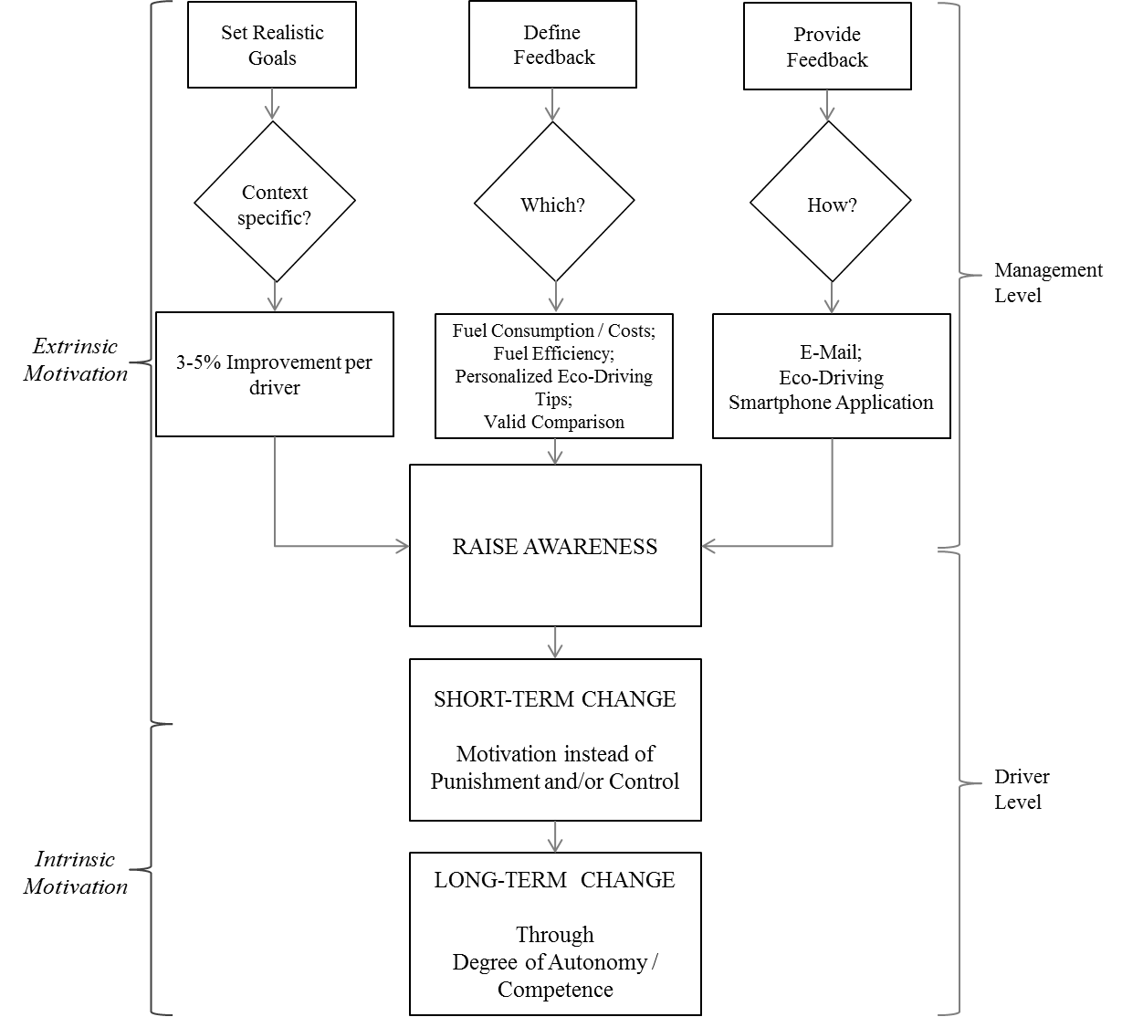

Table 2: Motivation concept within an organizational roll-out

***Recommendation 1: Set realistic goals***

Behavioral change should be goal directed, which makes goal setting essential for stimulating change (Kluger & DeNisi, 1996). Realistic and context specific goals that respect the driver’s autonomy must be set to successfully provide an extrinsic motivator that enhances their intrinsic motivation. During this experiment a fuel efficiency improvement of 3.23% was achieved within eight weeks of using the eco-driving smartphone application without offering any other incentives. Studies have shown that reductions of up to 7.3% (Siero et al., 1989) are possible for postal lorry truck drivers if extrinsic incentives are enthused using realistic goal setting and positive management intervention. Based on the unique setting of corporate car drivers, results of this research, and with consideration to other studies, the company’s management is advised to set a realistic overall fuel efficiency improvement goal of between 3-5% per driver.

***Recommendation 2: Define feedback***

Software company’s corporate car drivers drive approximately 30,000 km/year or more without any knowledge of their average fuel consumption and fuel costs unless the driver has a personal interest. Fuel consumption and any costs (i.e. petrol or car maintenance) are reimbursed by the company but are not provided to the drivers. By exposing these details to drivers their fuel efficiency could immediately be influenced positively as their attention is actively directed to the feedback-standard gap (i.e. actual vs. expected fuel consumption). It is recommended that management provide this information. Improvement in information-flow is a first step in supporting corporate car drivers to develop an intrinsic motivation to drive more sustainably.

The provision of fuel consumption and cost figures in combination with a realistic improvement goal requires, in addition, constructive advice in the form of personalized and comprehensible information about eco-driving techniques. Alternatively, feedback should indicate their progress in driving more efficiently, thus enhancing driver’s intrinsic motivation. The driver has to recognize the positive impact he has in reducing CO2 emissions, feel competent in the task and maintain autonomy. Providing a valid comparison between the fuel efficiency of drivers driving the same vehicle model and similar number of kilometers per year can be an effective feedback type for inspiring motivation, as shown in the interview findings (see Table 1). The management should provide fuel cost, consumption and fuel efficiency information, offer personalized eco-driving tips, and provide a valid comparison between drivers driving the same vehicle model and a similar number of kilometers.

***Recommendation 3: Provide feedback***

How should the feedback required be provided? The findings revealed that the eco-driving smartphone application is a cost effective way to modify drivers’ driving behavior positively providing feedback during driving. It is recommended that the application should be incorporated in an organizational roll-out program to improve fuel efficiency. Furthermore, a monthly e-mail containing fuel consumption/ costs information, fuel efficiency feedback, personalized eco-driving tips, and a valid comparison between corporate car drivers’ fuel efficiency driving the same vehicle model and same amount of kilometers should be implemented.

The consideration of these feedback types should raise awareness among the corporate car drivers. Raising awareness is the initial and important step in promoting corporate car drivers to discover their intrinsic motivation to drive eco-friendly. The impact could be a short-term change in participants’ driving behavior as they are motivated to change and not punished or controlled to do so. Management is recommended to refrain from punishment with regards to goals set as this would result in employees feeling controlled, suppressing their autonomy and undermining their motivation. The long-term implementation of the recommendations, including raising awareness and increasing motivation, should lead to an enhancement of the corporate car drivers’ intrinsic motivation. An important factor contributing to this is the degree of autonomy and competence the drivers feel when they realize that they are not controlled or punished. It must be understood that enhancing intrinsic motivation is a gradual process.

1. **Conclusion**

This paper introduces a concept through which corporate car drivers can be motivated to reduce their fuel consumption, without the benefit of any financial reward. Eco-driving is a way through which fuel consumption resulting from road transport can be reduced. The very essence of the eco-driving concept is to empower drivers to modify their driving habits by adopting sustainable driving techniques prompted by feedback and advice given by an external source. This is where the utilization of an eco-driving application capable of providing eco-feedback is exciting, and so was investigated in its’ ability to influence corporate car drivers’ fuel efficiency. Statistical analysis of results from the field test conducted from October 2011 until December 2011 validated a statistically significant improvement in participants’ fuel efficiency by 3.23% (Tulusan et al., 2012). This seemingly small reduction in fuel consumption could translate to a petrol expenditure savings of 1.4 million Euros for the software company. The environmental benefit was also significant, as 618.16 kg of CO2 emissions were prevented from entering our atmosphere during the eight-week experimental period. When projecting this calculation over a timeframe of a year, the potential prevention of 4.02 tons of CO2 emissions from escaping into the atmosphere becomes unavoidable clear. Appraisal of the findings using the FIT by Kluger & DeNisi (1996), and the evaluation of extrinsic and intrinsic motivation revealed that it is imperative to stimulate drivers’ awareness of their fuel consumption. Feedback from the smartphone application enhanced participants’ awareness of their personal performance, and enabled them to modify their behavior when necessary (Grant & Higgins, 1989). Actively directing drivers’ attention to the difference between their driving style and recommended sustainable driving habits was essential to the process. Intrinsic motivation was captured by extrinsic motivations when self-determination and feelings of autonomy and competence were enhanced without making the participants feel controlled (Amabile, 1993). These corporate car drivers were concerned that management monitoring would lead to loss of autonomy and punishment if their fuel efficiency did not improve; this highlights the need to ensure that an organizational roll-out of this eco-driving concept is not associated with punishments, but the positive motivation and development of their drivers using realistic goal setting and the provision of constructive feedback (i.e. providing fuel efficiency figures from the same vehicle model).

1. **Limitations and Future Research**

Due to the relatively small sample size, 50 participants divided into two groups (control and treatment), it may not be possible to generalize the findings to other companies. However, these findings can provide a preliminary insight into what level of influence a mobile eco-feedback technology can have on corporate car drivers’ fuel efficiency. Due to the comprehensiveness of this research, the first generic concept suggesting how an eco-driving concept with the support of eco-feedback technologies can be rolled-out within an organization is described. However, the long-term improvements were not evaluated statistically but appraised using a qualitative approach (survey and semi-structured interviews). For the purpose of further research, a study with using corporate car drivers in another region is planned. This region has 9000 corporate car drivers, enabling access to a larger sample size.

# Bibliography

1. Amabile, T.M., 1993. Motivational Synergy: Toward New Conceptualizations of Intrinsic and Extrinsic Motivation in the Workplace. *Human Resource Managment Review, Vol. 3*, pp.185-201.
2. Austrian Energy Agency, 2012. *EcoDrive*. [Online] Available at: http://www.ecodrive.org [Accessed 18 April 2012].
3. Autoflotte, 2008. Wüster Fahrstil, ade! *Autoflotte*, November. p.65.
4. Babchuk, W.A., 1997. *Glaser or Strauss: Grounded Theory and Adult Education*. East Lansing, Michigan.
5. Beswick, D., 2007. *Management implications of the interaction between intrinsic motivation and extrinsic rewards*. [Online] Available at: http://www.beswick.info/psychres/management.htm [Accessed 21 April 2012].
6. Boriboonsomsin, K., Vu, A. & Barth, M., 2010. *Co Eco-Driving: Pilot Evaluation of Driving Behavior Changes among U.S. Drivers*. Riverside: University of California Transportation Center.
7. De Young, R., 1986. Encouraging Environmentally Appropriate Behvaiour: The Role of intrinsic Motivation. *Environmental Systems, Vol. 15(4)*, pp.281-91.
8. Deci, E.L. & Ryan, R.M., 1985a. *Intrinsic motivation and self-determination in human behavior*. New York: Plenum.
9. Drive Gain Ltd, 2011. *Drive Gain Ltd. Web site*. [Online] Available at: http://drivegain.com/ [Accessed 15 February 2012].
10. DTLR, 2012. *Department for Transport statistics 2011*. [Online] Available at: http://www.dft.gov.uk/statistics/releases/tsgb-2011-vehiDW [Accessed February 2012].
11. European Commission, 2011. *Climate Action: Policies*. [Online] Available at: http://ec.europa.eu/dgs/clima/mission/index_en.htm [Accessed 1 March 2012].
12. Froehlich, J. et al., 2009. UbiGreen: investigating a mobile tool for tracking and supporting green transportation habits. *Proceedings of the 27th international conference on Human factors in computing systems*, p.1043–1052.
13. Grant, R. & Higgins, C., 1989. Monitoring service workers via computer: The effect on employees, productivity, and service. *National Productivity Review, Vol. 8(2)*, pp.101-12.
14. GreenRoad. (2008). Is Safe Driving More Economical? Driver Safety and Fuel Consumption. [online]. Available from: http://www.greenroadtech.com/documents/driver_safety_and_fuel_consumption_us.pdf [Accessed May 29, 2011].
15. Keller, S. & Conradin, K., 2010. *Semi-Structured Interviews*. [Online] Available at: http://www.sswm.info/category/planning-process-tools/exploring/exploring-tools/preliminary-assessment-current-status/semi [Accessed 7 March 2012].
16. Kluger & DeNisi, 1996. The Effects of Feedback Interventions on Performance: A Historical Review, a Meta-Analysis, and a Preliminary Feedback Intervention Theory. *Psychological Bulletin, Vol. 119(2)*, pp.254-84.
17. Kraftfahrt-Bundesamt, 2012. *Monatliche Neuzulassungen - Neuzulassungsbarometer im Dezember 2011*. [Online] Available at: http://www.kba.de/cln_031/nn_330190/DE/Statistik/Fahrzeuge/Neuzulassungen/MonatlicheNeuzulassungen/201112GV1monatlich/201112__n__barometer__teil2__tabelle.html [Accessed 3 March 2012].
18. Moghaddam, A., 2006. Coding issues in grounded theory. *Issues in Educational research, Vol. 16*, pp.52-66.
19. Nussbaum, K., & duRivage, V. (1986). Computer monitoring: Mismanagement by remote control. Business and Society Review, 56, 16−20.
20. Onoda, T., 2009. IEA policies–G8 recommendations and an afterwards. *Energy Policy, Vol. 37(10)*, p.pp.3823–3831.
21. Romm, J.J. and Frank, A.A. (2006). Hybrid vehicles gain traction. *Scientific American*, 294(4), pp.72–79.
22. Rotter, J.B., 1966. Generalized expectancies for internal versus external control of reinforcement. *Psychological Monographs: General and Applied, Vol. 80*, pp.1-28.
23. SenterNovem, 2006. *Ecodriving The smart driving style*. Utrecht: EC TREATISE Project.
24. Shipworth, M., 2002. *Motivating Home Energy Action: A Handbook of What Works.* [Online] Australian Greenhouse Office Available at: http://www.greenhouse.gov.au/coolcommunities/ motivating/index.html [Accessed 3 May 2012].
25. Shute, Valerie J. 2007. 1–44 *Focus on Formative Feedback*. Princeton, NJ: Educational Testing Service. Research Report. http://www.ets.org/Media/Research/pdf/RR-07-11.pdf (Accessed June 24, 2012).
26. Siero, S., Boon, M., Kok, G. & Siero, F., 1989. Modification of Driving Behavior in a Large Transport Organization: A Field Experiment. *Journal of Applied Psychology, Vol. 74(3)*, pp.417-23.
27. Stoney Alder, G., 2007. Examining the relationship between feedback and performance in a monitored environment: A clarification and extension of feedback intervention theory. *Journal of High Technology Management Research, Vol. 17*, pp.157-74.
28. Strauss, A. & Corbin, J., 1998. *Basics of qualitative research: Techniques and procedures for developing grounded theory*. Thousand Oaks: Sage.
29. Tulusan, J., Staake, T., Fleisch, E., ***Providing eco-driving feedback to corporate car drivers: what impact does a smartphone application have on their fuel efficiency,*** 14th ACM International Conference on Ubiquitous Computing (UbiComp), Pittsburgh, Pennsylvania, United States, September 2012.
30. van der Voort, M., Dougherty, M.S. and van Maarseveen, M. (2001). A prototype fuel-efficiency support tool. *Transportation Research Part C: Emerging Technologies*, 9(4), pp.279–296.
31. Zahorsky, D., 2010. *Ignite the Two Fires of Employee Motivation*. [Online] Available at: http://sbinformation.about.com/cs/benefits/a/033003.htm [Accessed 21 April 2012].

1. EMEA region even 38%, 103.0 kTons